Right Click vào project chọn Properties:
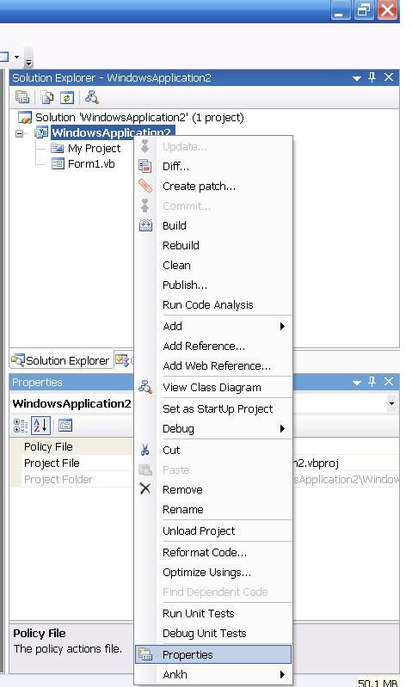

Trong Tab Application chọn View Application Events:
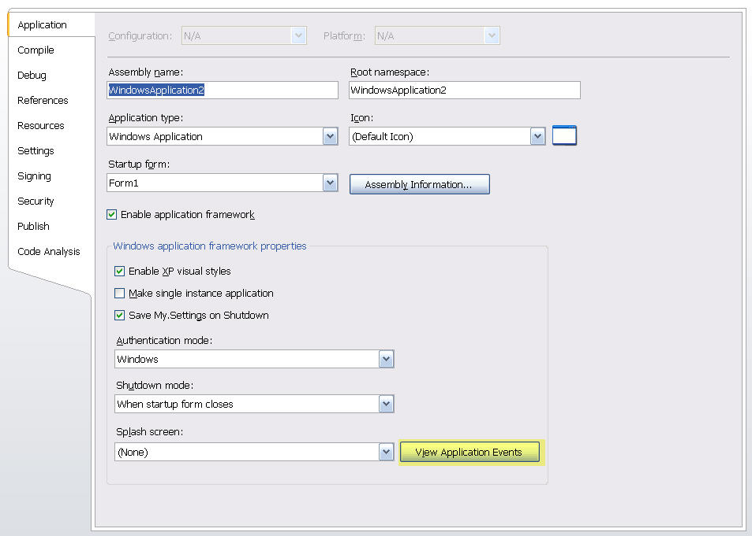

File ApplicationEvents được tạo ra:
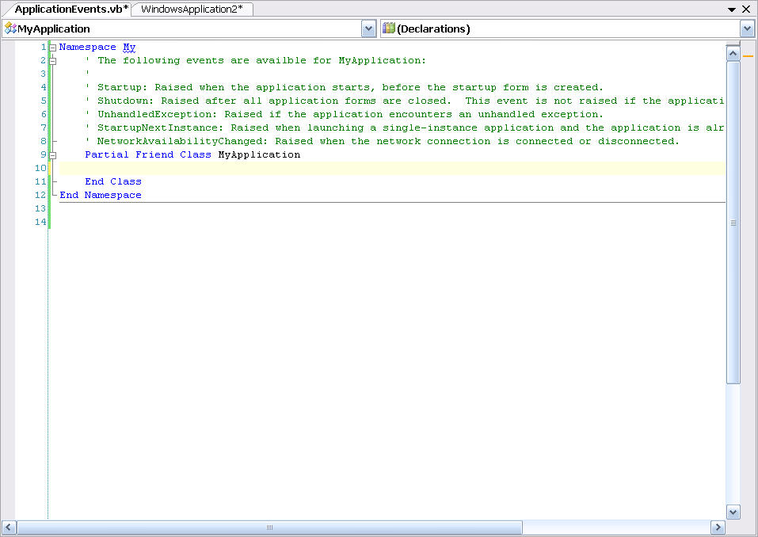

Chọn event UnhandledException:
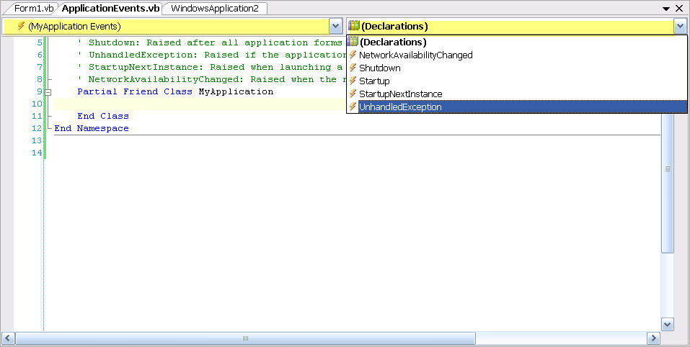

Để bắt tất cả exception, trong lớp file Program.cs thêm vào những dòng highlight sau:
Namespace My
' The following events are availble for MyApplication:
'
' Startup: Raised when the application starts, before the startup form is created.
' Shutdown: Raised after all application forms are closed. This event is not raised if the application terminates abnormally.
' UnhandledException: Raised if the application encounters an unhandled exception.
' StartupNextInstance: Raised when launching a single-instance application and the application is already active.
' NetworkAvailabilityChanged: Raised when the network connection is connected or disconnected.
Partial Friend Class MyApplication

Private Sub MyApplication_UnhandledException(ByVal sender As Object, _
ByVal e As _
Microsoft.VisualBasic.ApplicationServices. _
UnhandledExceptionEventArgs) Handles Me.UnhandledException
Dim message As String
message = "An unhandled exception occurs." + Constants.vbCrLf + "Error description: " + e.Exception.Message + _
Constants.vbCrLf + "Error detail: " + e.Exception.StackTrace() + Constants.vbCrLf + _
"Please contact ..."
MessageBox.Show(message, "Error", MessageBoxButtons.OK, MessageBoxIcon.Error)
'Write to logfile
e.ExitApplication = False
End Sub
End Class
End Namespace

